Weekly Virtual Visit Overview

 | Place | Capital city | Language | Landmarks | Flag | Size (village, town,city or country) | Climate | What is it famous for?
1 | Plympton | London | English | Plympton Castle  Plympton St Maurice Church |   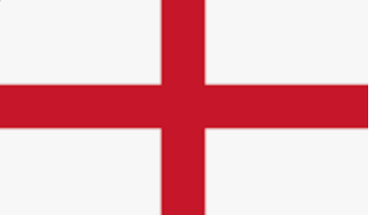  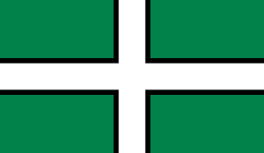 | Town | Summer - warm  Winter - cold  Seasonal changes | Plympton Castle  Birthplace of Artist Sir Joshua Reynolds (1723 - 1792)
2 | Plymouth | London | English | Smeaton’s Tower  Plymouth Argyle | 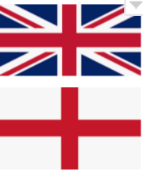 | City | Summer - warm  Winter - cold  Seasonal changes | Plymouth Dock /  Sir Francis Drake /  Plymouth Mayflower
3 | Exeter | London | English | Exeter Cathedral |  | City | Summer - warm  Winter - cold  Seasonal changes | Exeter Chiefs /  Dates back to the Roman era / Powderham Castle / Royal Albert Memorial Museum & Art Gallery (RAMM) / Medieval Underground Passages
 | Place | Capital city | Language | Landmarks | Flag | Size (village, town,city or country) | Climate | What is it famous for?
4 | London | London | English | London Eye/ Big Ben/ Houses of Parliament/ Buckingham Palace |  | City | Summer - warm  Winter - cold  Seasonal changes | Monarchy / Government / Landmarks / National Service of Remembrance / Red telephone boxes/ Buses/ Paddington
5 | London | London | English | London Eye/ Big Ben/ Houses of Parliament/ Buckingham Palace |  | City | Summer - warm  Winter - cold  Seasonal changes | Monarchy / Government / Landmarks / National Service of Remembrance / Red telephone boxes/ Buses/ Paddington
6 | Wales | Cardiff | Welsh/ English | Principality Stadium | 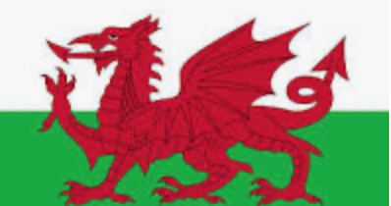 | Country | Summer - warm  Winter - cold  Seasonal changes | Snowdon
7 | Cardiff | Cardiff | Welsh/ English | Cardiff Castle |  | City | Summer - warm  Winter - cold  Seasonal changes | The birthplace of Roald Dahl
8 | Scotland | Edinburgh | Scottish | Loch Ness | 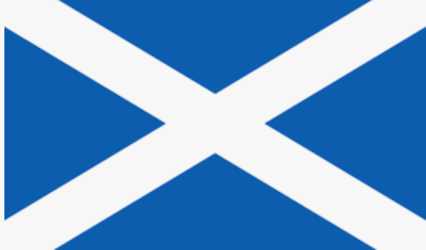 | Country | Summer - warm  Winter - cold  Colder than England generally  Seasonal changes | Ben Nevis  Haggis
 | Place | Capital city | Language | Landmarks | Flag | Size (village, town,city or country) | Climate | What is it famous for?
9 | Edinburgh | Edinburgh | Scottish | Edinburgh Castle | 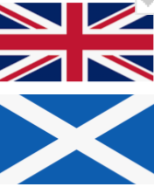 | City | Summer - warm  Winter - cold  Colder than England generally  Seasonal changes | Arthur’s seat  Edinburgh Castle
10 | Northern Ireland | Belfast | Irish | Titanic |  | Country | Summer - warm  Winter - cold  Seasonal changes | Irish Dance  Live music
11 | Belfast | Belfast | Irish | City Hall |  | City | Summer - warm  Winter - cold  Seasonal changes | Irish Dance  Live music
12 | Republic of Ireland | Dublin | Irish | The Spire of Dublin |  | Country | Summer - warm  Winter - cold  Seasonal changes | Irish Dance  Live music
13 | Dublin | Dublin | Irish | Dublin Castle | 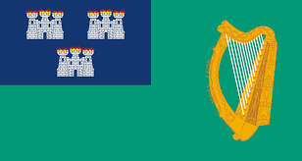 | City | Summer - warm  Winter - cold  Seasonal changes | Irish Dance  Live music
 | Place | Capital city | Language | Landmarks | Flag | Size (village, town,city or country) | Climate | What is it famous for?
15 | Liverpool | London | English | Royal Albert Dock | 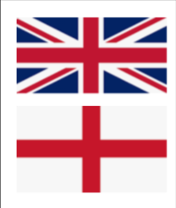 | City | Summer - warm  Winter - cold  Seasonal changes | The Beatles
16 | Swansea | Cardiff | Welsh/English | The Mumbles |  | City | Summer - warm  Winter - cold  Seasonal changes | Mumbles Pier
17 | Glasgow | Edinburgh | Scottish | Celtic Park/ Glasgow Cathedral |  | City | Summer - warm  Winter - cold  Colder than England generally  Seasonal changes | Whisky
18 | The Hoe | London | English | Smeaton’s Lighthouse  Drake’s Island |  |  | Summer - warm  Winter - cold  Seasonal changes | Fish and Chips  Pasties
 | Place | Capital city | Language | Landmarks | Flag | Size (village, town,city or country) | Climate | What is it famous for?
19 | The Barbican | London | English | Barbican harbour  Aquarium |  |  | Summer - warm  Winter - cold  Seasonal changes | Fish and Chips  Pasties
20 | Saltram | London | English | Saltram House |  |  | Summer - warm  Winter - cold  Seasonal changes
21 | Mount Edgcumbe | London | English/ Cornish | Mount Edgcumbe House  Mount Edgcombe Ferry |  |  | Summer - warm  Winter - cold  Seasonal changes | Being restored after WW2
 | Place | Capital city | Language | Landmarks | Flag | Size (village, town,city or country) | Climate | What is it famous for?
22 | Wembury | London | English | Wembury Beach |  | Village | Summer - warm  Winter - cold  Seasonal changes
23 | Bovisands | London | English | Bovisands Beach |  | Village | Summer - warm  Winter - cold  Seasonal changes
24 | River Plym | London | English | Plym Valley Railway  Cadover Bridge  Shaugh Prior Bridge  Bickleigh Bridge |  | n/a | Summer - warm  Winter - cold  Seasonal changes | Plymouth took its name from the river.  Popular for canoeing  Plym Valley Railway
25 | River Tamar | London | English |  |  |  | Summer - warm  Winter - cold  Seasonal changes
26 | Plymbridge | London | English | Plymbridge Woods |  |  | Summer - warm  Winter - cold  Seasonal changes
27 | Cann Woods | London | English |  |  |  | Summer - warm  Winter - cold  Seasonal changes
28 | Dartmoor | London | English | The Rock  River Dart  Buckfast Abbey  Buckland Abbey  Lydeford Gorge  Castle Drago  Dartmoor Prison |  | N/a | Summer - warm  Winter - cold  Seasonal changes | Dartmoor Prison  Sherlock Holmes  Myths and Legends - headless horseman  Dartmoor ponies
29 | Buckfast Abbey | London | English | Monastery  Abbey Church  Exhibition centre |  | N/a | Summer - warm  Winter - cold  Seasonal changes | Bees  Honey  Roman Catholic beliefs  Monks
30 | Torquay | London | English | Torquay Harbour  Torre Abbey |  | Buckfast - Village | Summer - warm  Winter - cold  Seasonal changes | Being known as the English Riviera
31 | Paignton | London | English | Paignton Zoo  Paignton Pier |  | Town | Summer - warm  Winter - cold  Seasonal changes | Paignton Zoo and arcades on the pier
32 | Brixham | London | English | Brixham Harbour  Berry Head Nature Reserve |  | Town | Summer - warm  Winter - cold  Seasonal changes | Harbour, tourism trade, fishing industry, and natural beauty
33 | Kingsbridge | London | English | Start Point Lighthouse |  | Town | Summer - warm  Winter - cold  Seasonal changes | Market town
34 | Salcombe | London | English | Salcombe Harbour |  | Town | Summer - warm  Winter - cold  Seasonal changes | Coasts, beaches, pristine water, maritime history.
35 | Dartmouth | London | English | Dartmouth Castle  River Dart |  | Town | Summer - warm  Winter - cold  Seasonal changes | Dartmouth castle, military fort, St Saviours Church
36 | France | Paris | French | Eiffel Tower  Louvre Museum  Arc De Triomphe  Palace of Versailles  Notre-Dame Cathedral |  | Country | East - - Summers - warm  Winters - cold.  South - Summers - hot. Winters - mild and dry. | Culture, food, Eiffel Tower, Culture, Louvre, Wine, Food.
37 | Paris | Paris | French | Eiffel Tower  Louvre Museum  Arc De Triomphe  Palace of Versailles  Notre-Dame Cathedral  Disneyland Paris | 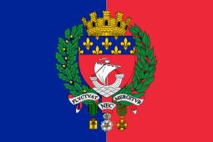 | City | Overall - mild and moderately wet.  Summer - warm and fair amount of sunshine. | Art,  Architecture, culture, fashion, food, wine
38 | Spain | Madrid | Spanish | La Sagrada Familia  Royal Palace of Madrid  Parc Guell | 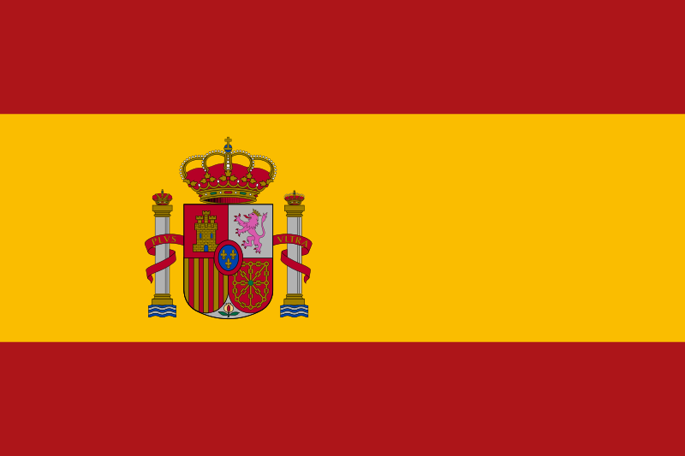 | Country | Hot and dry summers as well as cold and dry winters with a big contrast between day and night. | Paella  Tapas  Flamenco dancing  La alhambra  La Sagrada Familia
39 | Madrid | Madrid | Spanish | Royal Palace of Madrid  La Puerta de Alcalá  Prado Museum  Museo Cerralbo.  Plaza de Toros de Las Ventas.  Casa de Campo. | 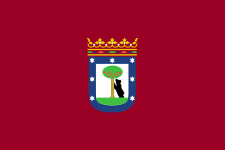 | City | Hot summers and relatively cool winters with somewhat frequent frosts (15 days have lows under 0 °C (32 °F) on average) and occasional snowfalls, with 3-4 snowy days on average.
40 | Portugal | Lisbon | Portuguese | Torre de Belem  Jeronimos Monastery  Cristo rei Statue  Castelo de São Jorge  Alcobaca Monastery  Castelo de Mouros  National Palace of Pena | 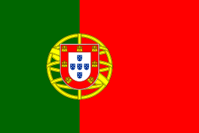 | Country | Portugal is mainly characterized by a warm temperate, mediterranean climate with a distinct wet season in winter. During winter, Portugal experiences a similar temperature pattern to the Spanish coastal towns, i.e. average daytime maxima of about 16°C (61°F). | Port (wine)  Pasteis de nata  Piri piri chicken  Football - ronaldo
41 | Lisbon | Lisbon | Portuguese | Torre de Belem  . Castelo de Sao Jorge · Panteao Nacional · Praca do Comercio · Jeronimos Monastery ·. Sintra. | 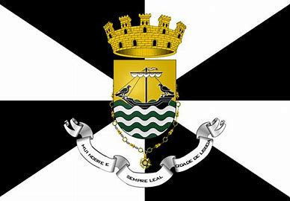 | City | Lisbon and its metropolitan area feature a mild Mediterranean climatewith short, mild and rainy winters and warm to hot, dry summers. Lisbon has a warm-temperate subtropical climate | charming old neighborhoods, colorful architecture, old-fashioned trams, delicious food, and rich history.
 | Year 2 - Term 2
 | Place | Capital city | Language | Landmarks | Flag | Size (village, town,city or country) | Climate | What is it famous for?
42 | Germany | Berlin | German | Cologne cathedral  Brandenburger Tor  Neuschwanstein Castle  Heidelberg Castle | 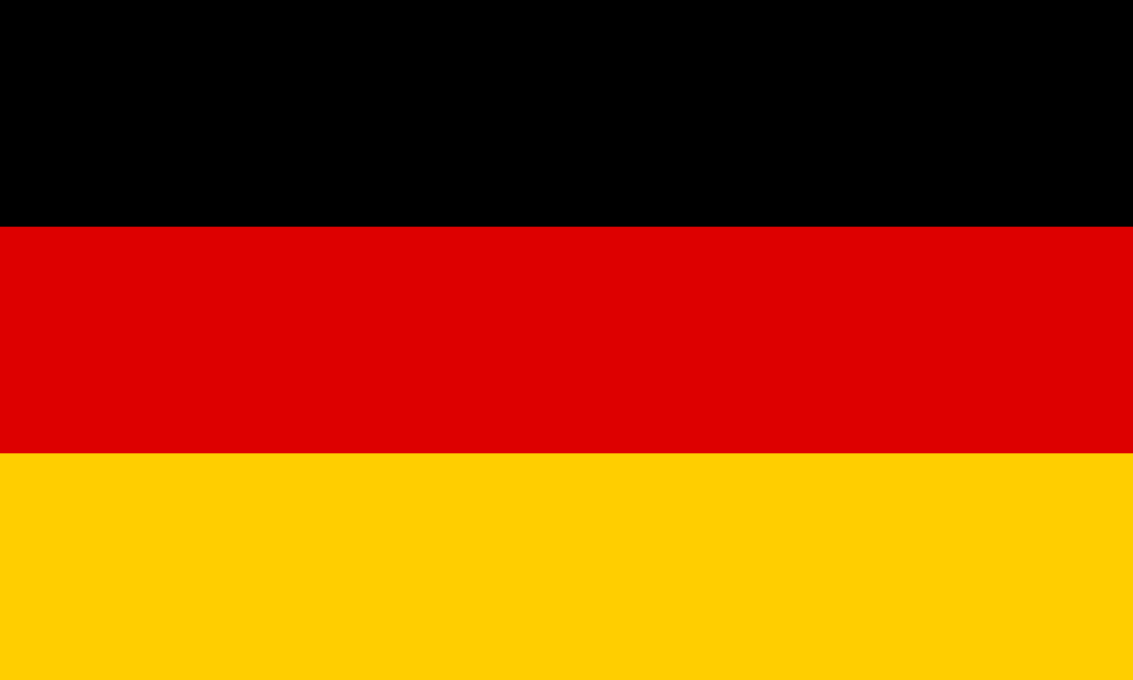 | Country | Germany's climate is temperate and marine in the west and humid continental in the east. It has cool winters in the west and cold winters in the east. It has moderate rainfall year-round and is mostly overcast from November to February. Summers are warm, more so in the south. | Castles,  Currywurst  Oktoberfest  Beer  Autobahn
43 | Berlin | Berlin | German | Reichstag  Brandenburg Gate  Fernsehturm  Alexander Platz  Checkpoint Charlie  Berlin Wall | 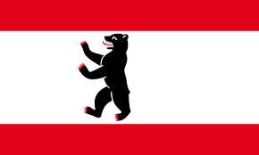 | City | Germany's climate is temperate and marine in the west and humid continental in the east. It has cool winters in the west and cold winters in the east. It has moderate rainfall year-round and is mostly overcast from November to February. Summers are warm, more so in the south. | Berlin is the city of art, artists and museums. In fact, precious artefacts from all over the world are showcased at more than 170 museums here, some of which can be found on the internationally renowned Museum Island.
44 | Austria | Vienna | German | Hofburg Palace, Vienna. Few historical landmarks in Austria are quite as iconic as the Hofburg. ...  St. Stephen's Cathedral, Vienna. ...  Schönbrunn Palace, Vienna. ...  Fortress Hohensalzburg, Salzburg. ...  Mirabell Palace, Salzburg. ...  Hallstatt Old Town, Gmunden. | 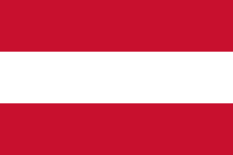 | Country | the climate of Austria can be classified as Cfb Climate; a warm temperated humid climate with the warmest month lower than 72 degrees Fahrenheit (22 degrees Celsius) over average and four or more months above 50 (10 degrees Celsius) over average. | Austria is particularly known for its classical music, folk music, baroque architecture, coffee culture, winter sports and Alpine traditions.  Austria is historically a strongly Catholic country, having been the centre of the Habsburg monarchy (1273–1918) which championed Roman Catholicism.
45 | Vienna | Vienna | German | Hofburg Palace  Mozarthaus  Schonbrunn palace  St Stephen’s cathedral | 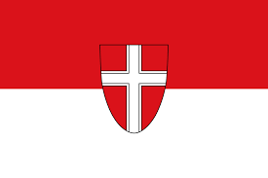 | City | The climate of Vienna is moderately continental, with cold winters and warm summers | The city of music  Beethoven, Brahms, Bruckner, Haydn, Mahler, Mozart, Schoenberg, Schubert, Johann Strauss I and Johann Strauss II lived and worked there
46 | Belgium | Brussels | Dutch/ French | Hallerbos  Grotte de Hotten  Minnewater Lake  Rocher Bayard  Reinhardstein waterfall | 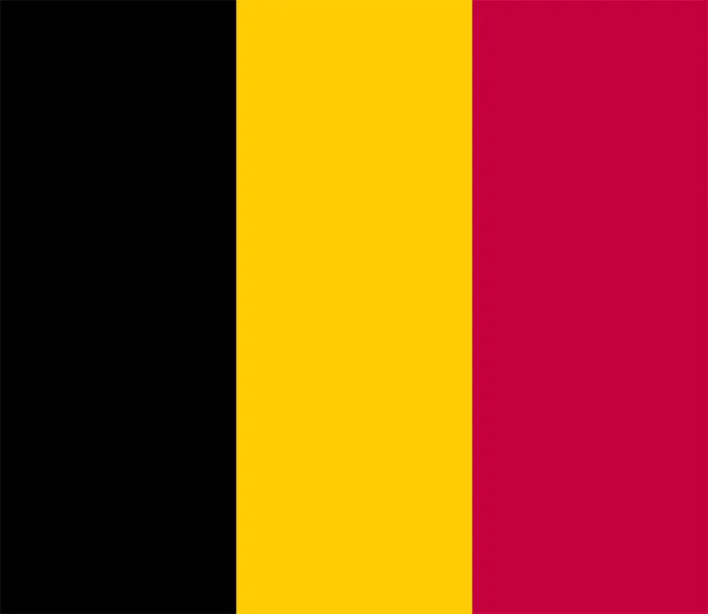 | Country | Belgium has a temperate maritime climate characterized by moderate temperatures, prevailing southerly to westerly winds, abundant cloud cover and frequent precipitation. Summers are relatively cool and humid and winters relatively mild and rainy. | Belgian Chocolate  Beer  Music festivals  Waffles
47 | Brussels | Brussels | Dutch/ French | Grand Palace  Atomium  Stadhuis  Royal Palace | 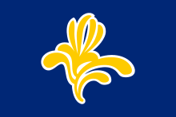 | City | Belgium has a temperate maritime climate characterized by moderate temperatures, prevailing southerly to westerly winds, abundant cloud cover and frequent precipitation. Summers are relatively cool and humid and winters relatively mild and rainy. | Brussels is often referred to as the "Capital of Europe" because it hosts several major international institutions including the headquarters of the European Union (EU) and NATO.
 | Year 2 - Term 3
 | Place | Capital city | Language | Landmarks | Flag | Size (village, town,city or country) | Climate | What is it famous for?
48 | Italy | Rome | Italian | Colosseum  Tower of Pisa  Duomo di Milano  Roman Forum | 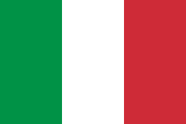 | Country | The majority of Italy follows a standard Mediterranean climate, with hot (hot) summers and pretty mild winters and much of the rainfall occurring in autumn and spring. However, there are some regions with different weather patterns. | Italy is well-known for its architecture, culture, art, opera, literature, film, and fashion. This is one of the best countries to go on a foreign tour.
49 | Rome | Rome | Italian | Colosseum  Trevi Fountain  Pantheon  Roman Forum |  | City | Rome has a Mediterranean climate with cool winters and warm and hot summers. | Rome is often referred to as the City of Seven Hills due to its geographic location, and also as the "Eternal City". Rome is generally considered to be the cradle of Western civilization and Western Christian culture, and the centre of the Catholic Church.
50 | Greece | Athens | Greek | Acropolis of Athens  Meteora  Parthenon  Mount Olympus | 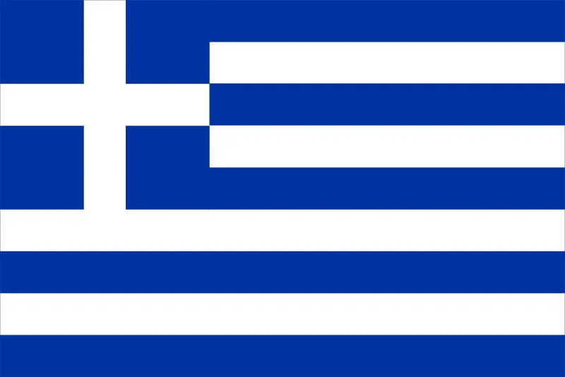 | Country | Greece has a Mediterranean climate, with mild and wet winters in the southern lowland and island regions and cold winters with strong snowfalls in the mountainous areas in the central and northern regions and hot, dry summers. | Greece is known for is its remarkably preserved ruins, as well as its many archaeological museums
51 | Athens | Athens | Greek | Mount Lycabettus  Temple of Olympian Zeus |  | City | Temperatures rarely fall below 10°C in winter and can rise as high as 27°C in the summer. | Birthplace of democracy, arts, science and philosophy of western civilisation. Home of Plato, Socrates, Pericles, Euripides, Sophocles, Aeschylus. Athens is one of the world's oldest cities.
52 | Switzerland | Bern | German/ French | Chillon Castle  Chapel Bridge  Rhine Falls  The Geneva Water Fountain |  | Country | Switzerland is situated in a temperate climatic zone. There are no extremely cold winters or extremely hot summers | Switzerland is famous for its mountains, clocks and its food – especially cheese and chocolates.
53 | Bern | Bern | German/ French | Zytglogge  UNESCO  Cathedral of Bern  The Pariament Building |  | City | Bern has a Marine west coast, warm summer climate | Perhaps the most famous Bern landmark is the bear pit, where bears have been kept on display at the city's expense since 1480
 | Place | Capital city | Language | Landmarks | Flag | Size (village, town,city or country) | Climate | What is it famous for?
54 | Ukraine | Kiev | Ukrainian | Potemkin Stairs  Ukrainian Motherland Monument | 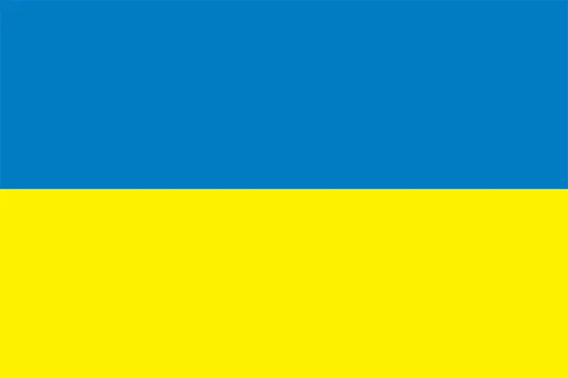 | Country | Ukraine has a mostly temperate climate, with the exception of the Southern Coast of Crimea which has a subtropical Mediterranean climate. | Ukraine is often called the “Breadbasket of Europe” because it boasts the ideal conditions for growing wheat, and is a major producer of the stuff.
55 | Kiev | Kiev | Ukrainian | Golden Gate  St. Andrew’s Church  St Michael’s Golden-Domed Monastery |  | City | warm-summer humid continental climate | an important industrial, scientific, educational, and cultural centre in Eastern Europe.
56 | Croatia | Zagreb | Croatian | Diocletian’s Palace  Krka National Park  Golden Horn Beach | 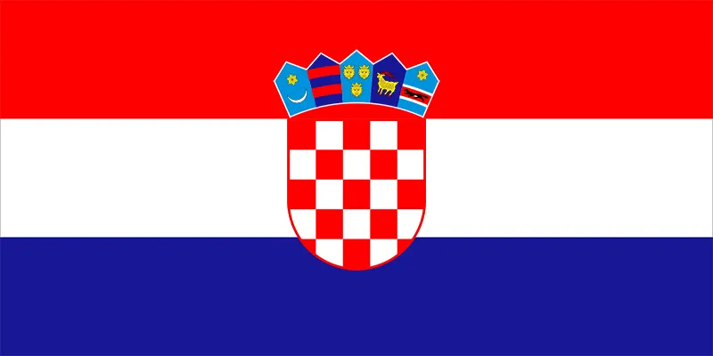 | Country | Croatia has two climates as the interior is separated from the coast by the Dinaric Mountains. The interior experiences a continental climate with hot summers and cold, snowy winters, while coastal areas have a Mediterranean climate with hot, dry summers and short, mild and somewhat wet winters. | Croatia is known for its beaches, with close to 2,500 miles of coastline between its islands and the mainland.
57 | Zagreb | Zagreb | Croatian | Cathedral of Zagreb  Stone Gate  Church of St. Mark |  | City | The climate of Zagreb has an average yearly temperature of 19°C. Throughout the year, the average monthly temperature can drop to 8°C and rise to 29°C. | Zagreb is also known for its vibrant cultural scene, which includes music, theatre, art, and film.
58 | Bulgaria | Sofia | Bulgarian | Tsarevets Fortress  Rila Monastery  Ancient Theatre of Philippopolis | 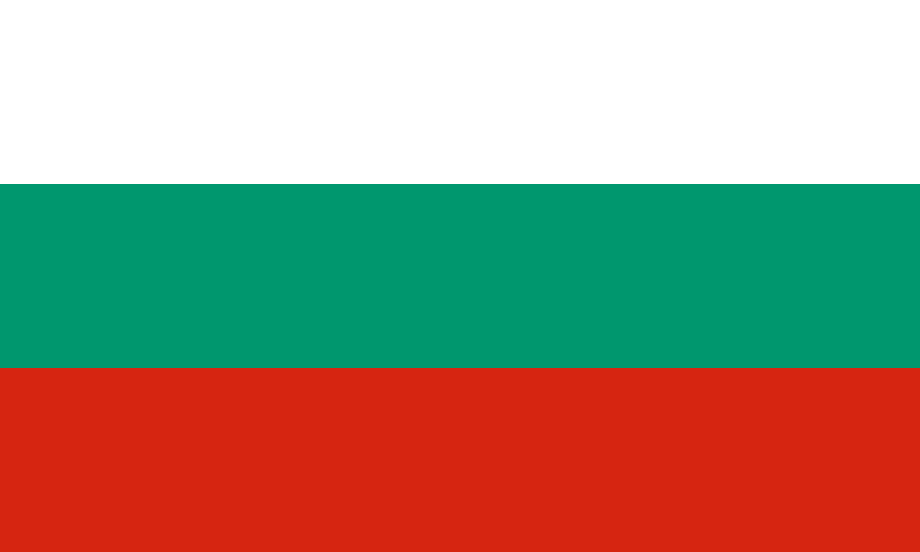 | Country | Bulgaria is characterised by two climatic regions: a continental climate in the north and a Mediterranean climate in the south. The country's Mediterranean climate tends to be hot and dry in the summers and cool in winters. | The country is remarkable for its variety of scenery; its rugged mountains and relaxing Black Sea resorts attract many visitors.
59 | Sofia | Sofia | Bulgarian | Bonyana Church  National Palace of Culture |  | City | Sofia has a humid continental climate | The city is known for its 49 mineral and thermal springs. Artificial and dam lakes were built in the twentieth century
 | Place | Capital city | Language | Landmarks | Flag | Size (village, town,city or country) | Climate | What is it famous for?
60 | Norway | Olso | Norwegian | Akershus Fortress  Bryggen  The Royal Palace | 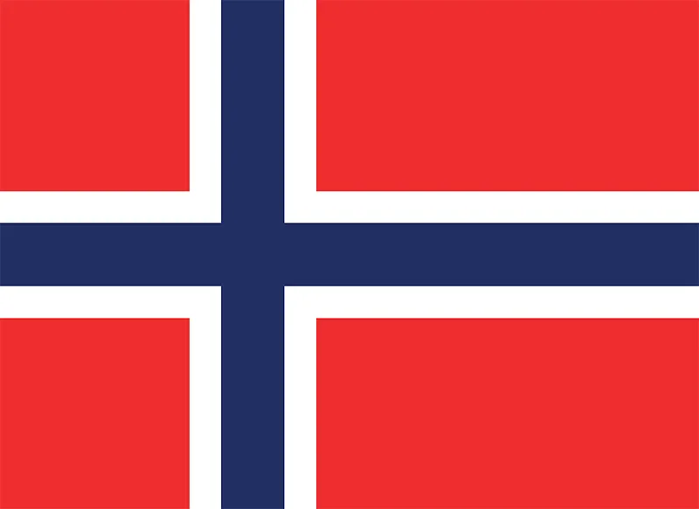 | Country | coastal areas have relatively mild and wet winters (but with snow in the mountains), while the inland regions have cold winters with plenty of snow, and hot and relatively dry summers, especially in the east of the country. | Soaring white mountains, breathtaking fjords, emerald-green forests, and exhilarating outdoor pursuits such as hiking and kayaking are a big part of what makes Norway famous.
61 | Oslo | Oslo | Norwegian | Munch  The Vigeland Park  Karl Johans Gate |  | City | Oslo has a humid continental climate | Oslo is famous for modern design and architecture, and the Oslo Opera House definitely stands out from the crowd.
62 | Sweden | Stockholm | Swedish | The Royal Palace  Drottningholm Palace  Oresund Bridge  Stockholm City Hall | 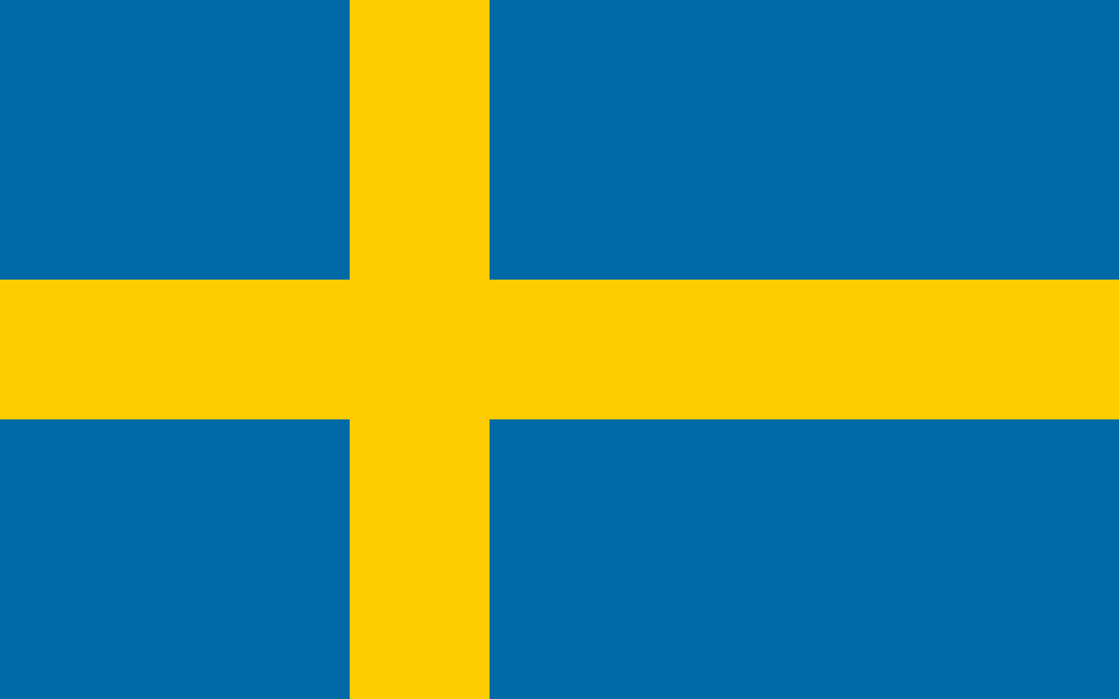 | Country | mild in the winter months, but the northernmost part of the country has a sub-Arctic climate with long, cold and snowy winters. | The country is famous for its innovative design, picturesque landscapes and rich history. The country has the highest number of non-religious population.
63 | Stockholm | Stockholm | Swedish | The Royal Palace  Stockholm City Hall  Grona Lund  Storkyrkan |  | City | Stockholm has a humid continental climate in the 0 °C isotherm | Stockholm, the largest city in Scandinavia, effortlessly intertwines a rich history and stunning nature with the cultural sophistication, modern architecture, and dynamic attitudes of a thriving metropolis.
64 | Finland | Helsinki | Finnish | Suomenlinna  Turku Castle  Temppeliaukio Church  Santa Claus Village | 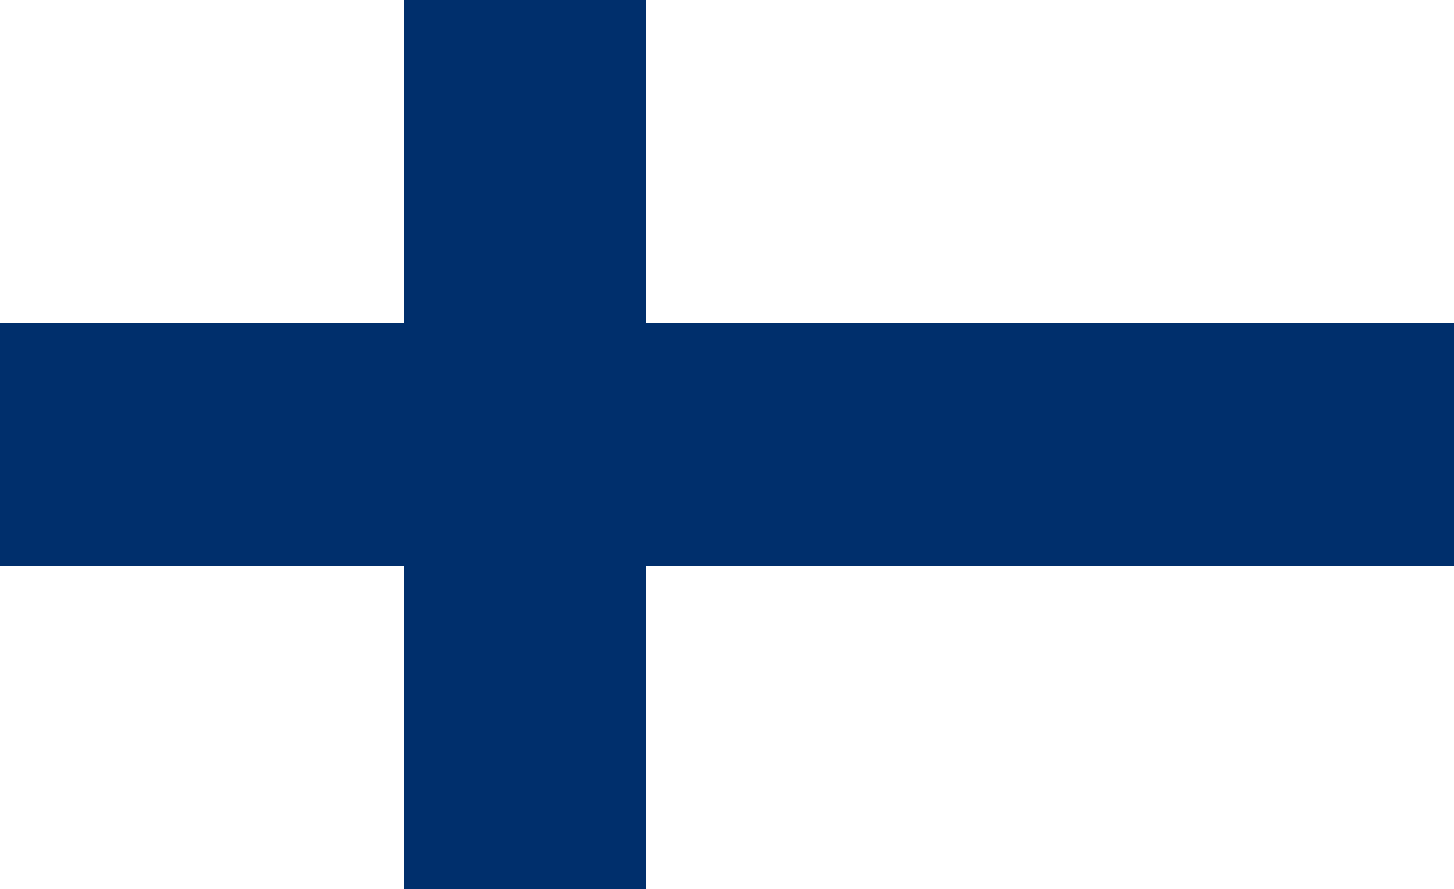 | Country | The climate of Finland displays features of both maritime and continental climates, depending on the direction of airflow. | Lakes  Forests  Saunas  Reindeer  Father Christmas
65 | Helsinki | Helsinki | Finnish | Senate Square  Helsinki Cathedral  Uspenski Cathedral |  | City | Helsinki has a humid continental climate | Helsinki is well-known for its innovative art, culture and architecture
 | Place | Capital city | Language | Landmarks | Flag | Size (village, town,city or country) | Climate | What is it famous for?
66 | Denmark | Copenhagen | Danish | Rosenborg Castle  Christiansborg Palace  The Round Tower  Tivoli Gardens | 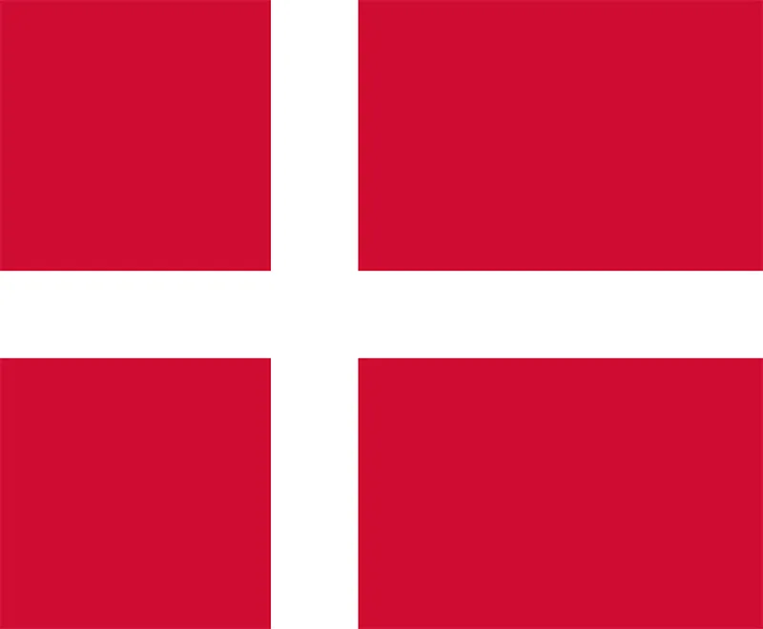 | Country | Denmark has a distinctly coastal climate, with mild, damp winters and cool, unsettled summers | food.  Design.  Culture.  Lego.  The Little Mermaid.  Danish Vikings.  Carlsberg beer.  Hygge.
67 | Copenhagen | Copenhagen | Danish | The Little Mermaid  Amalienborg Palace  Nyhavn |  | City | Its weather is subject to low-pressure systems from the Atlantic which result in unstable conditions throughout the year. | Beautiful waterways, historical buildings and modern architecture, world-class restaurants, and thousands of bikers -
68 | Iceland | Reykjavik | Icelandic | Blue Lagoon  Hallgrimskirkja  Thingvellir National Park  Sun Voyager | 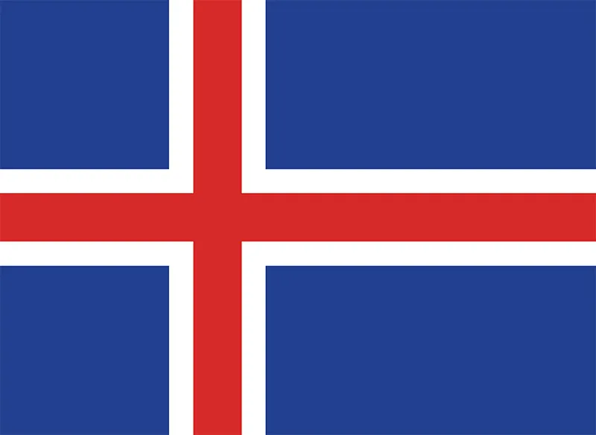 | Country | cool, temperate maritime climate with refreshing summers and mild winters. | Northern Light  The Golden Circle  Hot Springs  Black Sand Beaches
69 | Reykjavik | Reykjavik | Icelandic | Hallgrimskirkja  Perlan  Sun Voyager  The Settlement Exhibition |  | City | Iceland has a subpolar oceanic climate | Northern Lights  Blue Lagoon
70 | Russia | Moscow | Russian | The Moscow Kremlin  Red Square  Peterhof  Savior on the Spilled Blood | 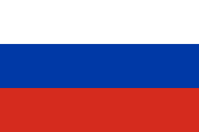 | Country | continental climate, with long, cold winters and brief summers. | Russia is known all over the world for its thinkers and artists, including writers like Leo Tolstoy and Fyodor Dostoevsky, composers such as Pyotr Ilyich Tchaikovsky, and ballet dancers including Rudolf Nureyev.
71 | Moscow | Moscow | Russian | Red Square  St. Basil’s Cathedral  All-Russian Exhibition Center |  | City | Moscow has a warm-summer humid continental climate with warm to hot summers and long, cold, winters. | Today Moscow is not only the political centre of Russia but also the country's most populous city and its industrial, cultural, scientific, and educational capital. For more than 600 years Moscow also has been the spiritual centre of the Russian Orthodox Church.
 | Place | Capital city | Language | Landmarks | Flag | Size (village, town,city or country) | Climate | What is it famous for?
72 | United States of America | Washington DC | English | The White House  Grand Canyon  Empire State Building  Niagara Falls  Golden Gate Bridge |  | Country | Generally, on the mainland, the climate of the U.S. becomes warmer the further south one travels, and drier the further west, until one reaches the West Coast. | Tourist Attractions  Technology innovation  Sports  Imprint on global culture  Food  Finance industry  NASA
73 | Statue of Liberty | New York City | English | Statue of Liberty |  |  | Humid subtropical climate | The statue is situated near Ellis Island, where millions of immigrants were received until 1943. Because of this, the Statue of Liberty is also understood to represent hope, freedom, and justice.
74 | The Grand Canyon | Arizona | English | Grand Canyon |  |  | Climate of Arizona Arizona’s climate is arid and semi-arid, with average annual precipitation ranging from 3 inches in the southwest at Yuma to around 40 inches in the White Mountains in east-central Arizona. | The Grand Canyon is known for its visually overwhelming size and its intricate and colourful landscape  One of the 7 natures of the world
75 | Yellowstone National Park | Wyoming | English | Yellowstone National Park |  |  | Wyoming’s climate is largely determined by its mid-latitude location in the interior of the North American continent, far from oceanic moisture sources. While its frequent proximity to the jet stream exposes it to periodic storm systems, its lack of easy access to moisture sources leads to a mostly semiarid climate | Yellowstone Park is the largest and most famous megafauna location in the contiguous United States. Grizzly bears, cougars, wolves, and free-ranging herds of bison and elk live in this park. The Yellowstone Park bison herd is the oldest and largest public bison herd in the United States.
76 | Niagara Falls | Ontario, Canada | English | Niagara Falls |  |  | Ontario's climate is continental, meaning the province experiences hot, humid summers and very cold winters with heavy snowfall. Spring and autumn tend to be milder. | Niagara Falls is a group of three waterfalls at the southern end of Niagara Gorge, spanning the border between the province of Ontario in Canada and the state of New York in the United States
77 | Golden Gate Bridge | San Francisco, California | English | Golden Gate Bridge |  |  | The climate of San Francisco can be defined as "Mediterranean with cool summers | The Golden Gate Bridge is an iconic structure connecting the city of San Francisco to Marin County, California. It spans almost two miles across the Golden Gate.
 | Place | Capital city | Language | Landmarks | Flag | Size (village, town,city or country) | Climate | What is it famous for?
78 | Mexico | Mexico City | Spanish | Tulum  Chichen Itza  Frida Kahlo Museum  Zona Arqueologica Palenque | 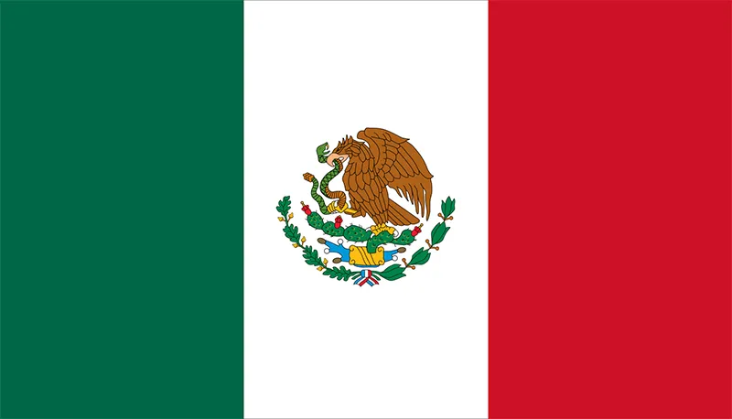 | Country | Mexico's a big country so the climate varies, but there are usually just two seasons, wet and dry. | Mexico is known for its rich culture, ancient ruins, dazzling beaches, and incredible cuisine.
79 | Brazil | Brasília | Spanish | Christ the Redeemer  Escadaria Selaron  Amazon Theatre |  | City | northern and central Brazil receives frequent rainfall and experiences higher temperatures. Meanwhile, southern Brazil is characterised by a humid subtropical climate. | It is most well known for its dense forests, including the Amazon, the world's largest jungle, in the north.
80 | The Amazon Rainforest | N/A | Portuguese, Spanish | No landmarks but famous for its forest trees, famous animals, river amazon | Brazil, Peru, Bolivia, Ecuador, Colombia, Venezuela, French Guiana, Guyana, Suriname  ( 60% of it lies in Brazil) | . The Amazon rainforest covers an enormous 6.7 million square kilometres. Spanning 8 countries  roughly 28 times the side of the UK | Humid and warm, the region has all the typical attributes of a tropical environment. Temperatures usually average 27.9 °C during the dry season, and 25.8 °C during the rainy season | The forest, animals- rainforest cover 3% of the planet but are home to more than half our planets animal species  , deforestation, climate  https://www.rainforest-alliance.org/everyday-actions/9-rainforest-facts-everyone-should-know/  Amazon rainforest | Ecosystems  Amazon Rainforest for Kids | Educational Videos for Kids | Wiz World Wonders  🌳🐒Amazon Rainforest Animals 4K🌍
81 | Chichen Itza | N/A | Spanish | El Castillo or Temple of Kukulcan | 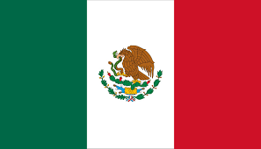 | Mexico | In Chichén-Itzá, the summers are short, sweltering, and partly cloudy; the winters are long, warm, and mostly clear; and it is muggy year round | The fusion of Mayan construction techniques with new elements from central Mexico make Chichen-Itza one of the most important examples of the Mayan-Toltec civilization in Yucatán. Several buildings have survived, such as the Warriors' Temple, El Castillo and the circular observatory known as El Caracol  Chichen Itza, Mexico in 4K  Chichén Itzá: The Great Mayan City - The Seven Wonders of the Modern World - See U in History  Chichen Itza in Mexico for kids | Seven wonders for kids| history & facts  Short Stories for Kids | Learn about Mexico  Short Stories for Kids | Learn about Mexico
82 | Machu Picchu | N/A | Spanish | Temple of the Moon, | 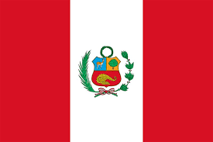 | Peru | Machu Picchu enjoys a pleasant subtropical weather year-round, making it an ideal destination for nature lovers and explorers. Expect warm days and cool nights, with average temperatures ranging between 12°C (54°F) and 24°C (75°F). Mornings and early hours tend to feel cooler. | Embedded within a dramatic landscape at the meeting point between the Peruvian Andes and the Amazon Basin, the Historic Sanctuary of Machu Picchu is among the greatest artistic, architectural and land use achievements anywhere and the most significant tangible legacy of the Inca civilization.  9 surprising facts about Machu Picchu | The Good Times by Intrepid  Machu Picchu, Peru 🇵🇪 - by drone [4K]  Guide to Machu Picchu for Children: Lost City of the Inca for Kids - FreeSchool
83 | Iguazu Falls |  | Guarani |  | 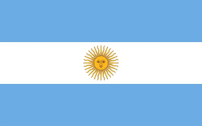
84 | The Sahara |  | Arabic |  | 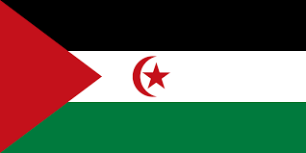
85 | Egypt | Cario | Arabic | Pyramids of Gi  Egypt's Valley of the King  Egypt's Valley of the Queens.  Great Sphinx of Giza. | 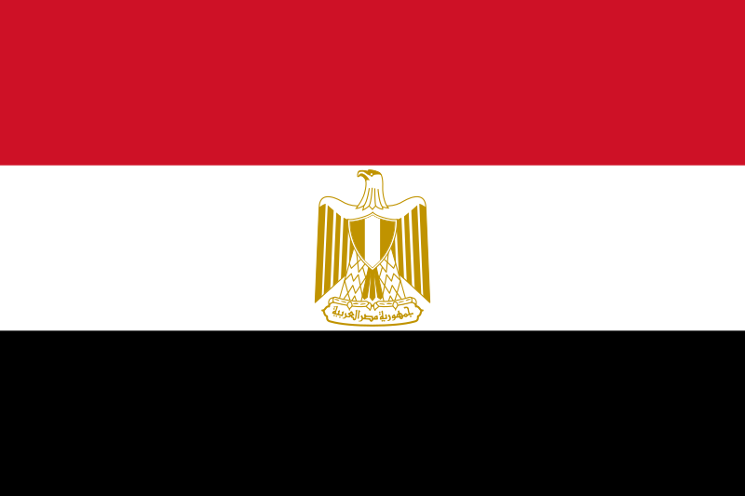 | Egypt is a country. It is the 30th largest country in the world by area. It is also the most populous Arab country. While most of Egypt is desert, the population is concentrated along the Nile River, where most cities and towns are located. | Egypt has a subtropical desert climate characterized by hot, dry summers and mild winters  Hot, dry, and dusty winds called "khamsin" can also occur, particularly between March and May. | Egypt is widely known for its rich ancient history, particularly its monumental pyramids, the Great Sphinx, and impressive temples like Luxor and Karnak.
86 | Kenya | Nairobi | Swahili  English | Nairobi National Park  Fort Jesus Museum  Tsavo East National Park  Uhuru Gardens | 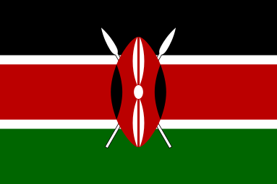 | A country in East Africa with coastline on the Indian Ocean. | Kenya has a tropical climate, but regional variations exist due to factors like altitude. It generally experiences two rainy seasons: the "long rains" (March-May) and the "short rains" (October-December). The dry season, with cooler temperatures, lasts from June to October. Temperatures range from 20°C to 28°C on average, but can be warmer on the coast and cooler in the highlands. | Kenya is widely known for its incredible wildlife and stunning natural landscapes, particularly its national parks and reserves, which are home to the "Big Five" (lion, leopard, elephant, buffalo, and rhinoceros) and the Great Migration of wildebeest. Beyond its wildlife, Kenya is also recognized for its vibrant culture, diverse ecosystems, and significant contributions to global sports and conservation.
87 | Serengeti National Park | Tanzania | Maa, also known as Masai | Naabi Hill Gate - Serengeti  Retima Hippo Pool  Osero Serengeti Tented Camp  Olduvai Gorge Museum | 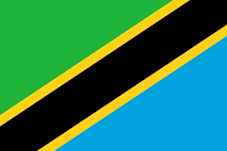 | The park lies in northwestern Tanzania, bordered to the north by the Kenyan border | The Serengeti National Park generally experiences a warm, dry climate with two rainy seasons: a longer one from March to May and a shorter one in November and December. Temperatures are moderate year-round, with daytime highs around 26°C (79°F) and nighttime lows around 14°C (57°F). | The Serengeti is well known for the largest annual animal migration in the world of over 1.5 million blue wildebeest and 250,000 zebra along with smaller herds of Thomson's gazelle and eland.  Home to black eagles. Black rhinos inhabit the granite outcrops of the Moru Kopjes.
88 | Victoria Falls | Zimbabwe | English, Shona, and Ndebele | Victoria Falls Bridge, which connects Zambia and Zimbabwe and is a popular spot for bungee jumping and walking between the two countries.  Livingstone Island- Situated on the edge of the falls, offering a unique perspective, particularly during the dry season  Devil's Cataract: The lowest of the five falls, with a 60m drop | 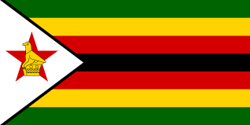 | Located on the Zambezi River at the border between Zambia and Zimbabwe | Victoria Falls experiences a subtropical climate with distinct wet and dry seasons. The dry season, from May to mid-August, is mild and dry with average high temperatures ranging from 25-27°C and lows between 7-10°C . The wet season, from mid-November to April, is characterized by hot, humid, and cloudy conditions with heavy rainfall, especially from January to March. October is typically the hottest month, with average temperatures reaching 27°C | It's recognized as one of the world's largest and most spectacular waterfalls,  The falls are one of the Seven Natural Wonders of the World.
89 | South Africa | South Africa has three capitals to balance power and reflect its political and cultural history. Pretoria, Cape Town, and Bloemfontein each host different branches of the South African government. | Afrikaans  Zulu  English  Tswana  Xhosa  Southern Sotho  Northern Sotho  Venda  Tsonga  Swati  South Africa Sign  Ndebele | Kruger National Park  Voortrekker Monument  V&A Waterfront  Constitution Hill Human Rights Precinct | 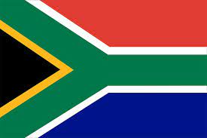 | South Africa is a country on the southernmost tip of the African continent | The weather in South Africa is quite pleasant. The climate is similar to that of southern California. | famous for its diverse landscapes, rich cultural heritage, and abundant wildlife, particularly the "Big Five" animals. It is also known for its role in ending apartheid, its world-class wines, and its contributions to sports and music.
90 | Mount Kilimanjaro | Tanzania | English and Swahili | Uhuru Peak: The highest point of Mount Kilimanjaro, reaching 5,895 meters (19,341 feet). Uhuru is the Swahili word for "freedom".  Stella Point: One of the three recognized summit points, located at 5,756 meters (18,885 ft).  Kibo Crater: The largest and main crater, situated near the summit. |  | Volcano In Tanzania, which is a country in East Africa | Mount Kilimanjaro has a varied climate due to its altitude, transitioning from warm and humid at the base to arctic conditions at the summit. The mountain experiences distinct climate zones, each with unique weather patterns, rather than traditional seasonal changes. | famous for being the highest mountain in Africa and the tallest free-standing mountain in the world. It is also a popular destination for climbers, attracting both experienced hikers and adventurers seeking to conquer the "Roof of Africa".
 | Place | Capital city | Language | Landmarks | Flag | Size (village, town,city or country) | Climate | What is it famous for?
91 | Australia | Canberra | English | Sidney Opera House  Uluru (Ayers Rock): A massive sandstone monolith in the heart of Australia, sacred to Aboriginal people.  Great barrier Reef: The world's largest coral reef system  The Twelve Apostles : ⁩⁦A collection of limestone stacks off the shore of Port Campbell National Park⁩⁦, | 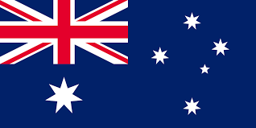 | Country in  Oceania | Australia has a diverse climate due to its large size and varied geography. The northern parts experience tropical climates with hot, humid summers and warm, dry winters, while the southern regions have more temperate conditions with mild summers and cool, sometimes rainy, winters. | Australia is famous for its unique wildlife, stunning natural landscapes, and vibrant culture.  Highlights include the Great Barrier Reef, Uluru (Ayers Rock), the Sydney Opera House, and diverse ecosystems featuring kangaroos, koalas, and other iconic animals.
92 | Uluru | southern part of the Northern Territory in central Australia | English | Uluru (Ayers Rock) and Kata Tjuta (The Olgas). Uluru is a massive sandstone monolith, while Kata Tjuta consists of 36 steep domes. These landmarks are both of great cultural significance to the local Anangu people and are listed as a UNESCO World Heritage site. | 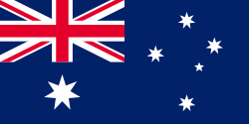 |  | Uluru has a hot desert climate characterized by extreme temperature variations between day and night, and throughout the year. Summers (December-February) are very hot, with average daytime temperatures reaching 35°C (95°F), and potentially exceeding 40°C (104°F). Winters (June-August) are mild, with daytime temperatures around 20°C (68°F) and nighttime temperatures dropping to around 4°C (39°F) | Uluru, also known as Ayers Rock, is famous for its impressive size, dramatic color changes, and deep cultural significance to the Aboriginal people. It's one of the world's largest monoliths, a massive sandstone formation that rises 348 meters above the desert floor. The rock's color shifts dramatically throughout the day, especially at sunrise and sunset, creating a breathtaking spectacle. Uluru is also a sacred site for the Anangu Aboriginal people, deeply intertwined with their culture, spirituality, and creation stories.
93 | Great Barrier Reef | Queensland, Australia | English | Whitehaven Beach in the Whitsundays, known for its pristine white sand, and various islands like Heron Island and Lady Musgrave Island, famous for marine life and diving spots. Other notable areas include the Cod Hole near Lizard Island, and the world's largest green turtle breeding area on Raine Island. |  |  | The Great Barrier Reef experiences a tropical climate characterized by warm temperatures and distinct wet and dry seasons. The dry season, from May to October, offers sunny skies and ideal conditions for snorkeling and diving. The wet season, from November to April, brings higher humidity, rainfall, and the possibility of tropical cyclones. | The Great Barrier Reef is the world's largest coral reef system, located off the northeastern coast of Australia. It stretches for over 2,300 kilometers (1,430 miles) and is composed of over 3,000 individual reefs and 900 islands.
94 | Sydney Opera House | Sydney | English |  |  |  | Sydney, the summers are warm and partly cloudy and the winters are short, cool, and mostly clear. Over the course of the year, the temperature typically varies from 47°F to 80°F and is rarely below 42°F or above 90°F. | The Sydney Opera House is a multi-venue performing arts centre in Sydney, New South Wales, Australia. Located on the foreshore of Sydney Harbour, it is widely regarded as one of the world's most famous and distinctive buildings, and a masterpiece of 20th-century architecture.
 | Place | Capital city | Language | Landmarks | Flag | Size (village, town,city or country) | Climate | What is it famous for?
95 | New Zealand | Wellington | Maori  English | Sky Tower-Iconic  Aukland landmark.  Fox Glacier  Hobbiton Movie set  Aoraki/ Mount Cook (Highest mountain) | 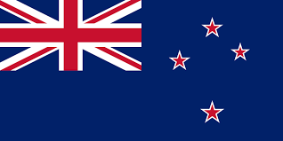 | An island country in the southwestern Pacific Ocean | New Zealand’s climate is diverse – the north of the North Island can have warm subtropical weather in summer, while inland alpine areas of the South Island can have heavy snow and temperatures as low as -10°C (14°F) in winter. | Whale watching  Haka  Manuka honey  Kiwi fruit  Hobbiton film set  Huka falls  Fiordland National Park and Milford Sound  Waitomo Caves
96 | Wellington New Zealand | Wellington | Maori  English | -The Beehive  -Cable car  -Te Papa Tongarewa | 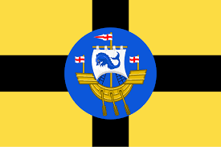 | Wellington is the capital city of New Zealand | Wellington has an oceanic climate, with mild, rainy winters (from June to August) and very mild summers (from December to March). Being in the southern hemisphere, the seasons are reversed compared to the northern hemisphere.  Wellington is the capital of New Zealand and is located in the southern part of the North Island, in the Cook Strait, which is very windy. In fact, Wellington is considered the windiest city in the world. | Windiest city  Wellywood
97 | Tasmania | Hobart | English | Cradle Mountain  Hastings Cave  Wineglass Bay Salamanca Market  The Museum of Old and New Art (MONA) Bonorong Wildlife Sanctuary to see Tasmanian Devils | 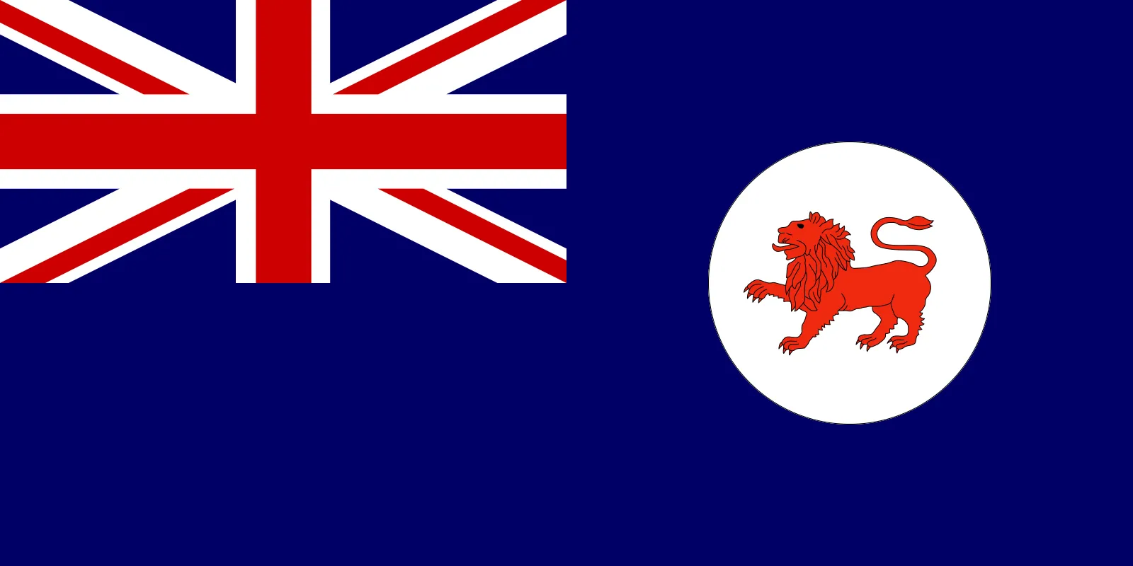 | An island country in the southwestern Indian Ocean | Tasmania, island state of Australia. It lies about 150 miles (240 km) south of the state of Victoria, from which it is separated by the relatively shallow Bass Strait. Structurally, Tasmania constitutes a southern extension of the Great Dividing Range. The state comprises a main island called Tasmania; Bruny Island, nestling close to the southeastern coast of the main island; King and Flinders islands in Bass Strait; numerous smaller islands off the coast of the main island; and subantarctic Macquarie Island, about 900 miles (1,450 km) to the southeast. The main island is roughly heart-shaped, with a maximum length and width of about 200 miles (320 km), and its latitude and climate are broadly comparable to those of northern California and northwestern Spain. With an area slightly larger than that of Sri Lanka, Tasmania is the smallest of Australia’s states. Hobart is the state capital | Tasmanian Devils
98 | Papua New Guinea | Port Moresby. | Tok Pisin  English  Hiri Motu |  | 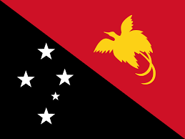 |  | generally experiences a tropical climate with high humidity and significant rainfall, particularly during the monsoon season. The country has two main seasons: a wet monsoon from December to March and a drier period influenced by trade winds from May to October | Papua New Guinea is renowned for its incredible biodiversity, rich cultural heritage, and abundant natural resources. It's famous for its diverse range of languages, vibrant tribal cultures, unique wildlife (especially birds of paradise), and significant mining industries

