

KS4

End of year 2018-2019 Pupil Progress Information

Contents

|  |  |
| --- | --- |
| **KS4 pupil progress information** | Pages 2-8 |
| Headlines | 2 |
| Progress information across English, Maths, ICT, LLfL, RE and PE | 2-8 |
| End of Year 11 outcomes | 8 |

**KS4 Pupil Progress Information End of Term 6 2018-2019**

**Headlines:**

* All pupils have met their end of KS4 targeted outcomes. 1 pupil exceeded target in Maths and English and 1 pupil exceeded target in ICT.
* 81% of all pupils making progress across English, Maths and ICT which is slightly more than Pupil Premium pupils (77%).
* Across the academic year **100% of pupils have made progress across all areas** (English, Maths, ICT, LLfL, RE, PE overall) with the exception of one Year 10 pupil in RE.

**Reading age assessment end of term 6 2018-2019 (based on a Reading Age test).**

*Further reading progress information is found in the progress through the curriculum and progress with HFW, phonics phases and book bands.*

**KS4 pupils:**

13% of our KS4 readers not yet at a functionally literate reading age of at least 9 years, this shows an improving picture from end of term 4. Overall a much improved picture for reading.

Of this 13% = 3 pupils, 1 pupil is Year 10 and 2 are Year 11. All 3 pupils are having an intensive reading program and reading daily with a consistent adult. All 3 made progress since end of Term 4 reading age assessment. The 2 year 11 pupils achieved EL2 in their English Functional Skills.

All KS4 pupils:

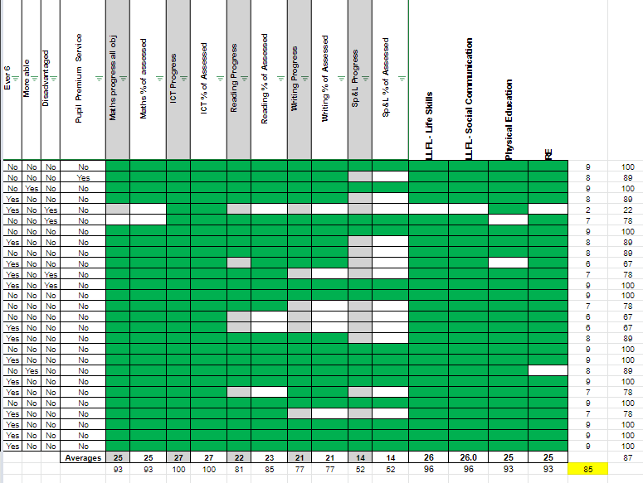

Same comparable average to end of Term 4 figure

Pupil Premium groups:

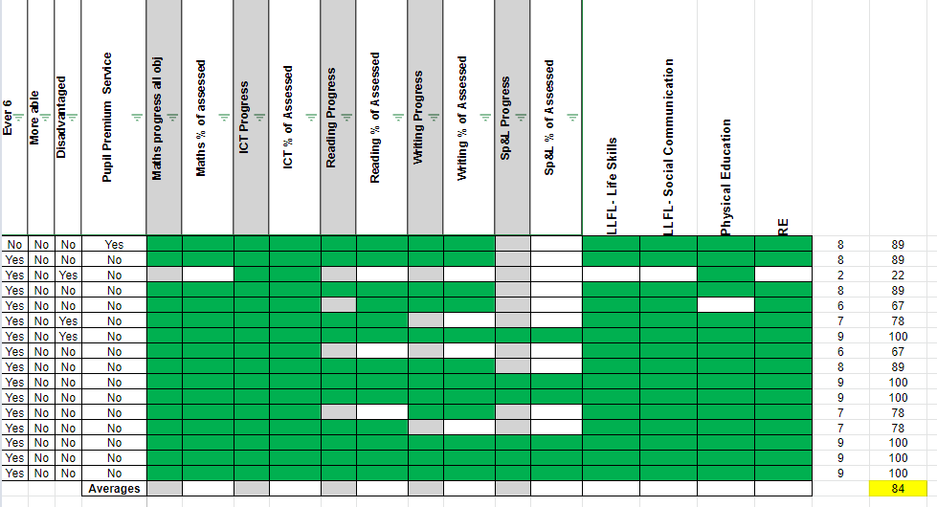

Slightly less than end of Term 4 comparable figure (88%) and slightly less than all pupils in KS4 (86%)

KS4 pupils - More able and disadvantaged:

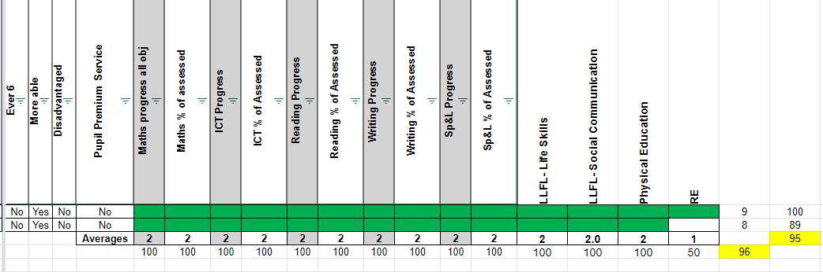

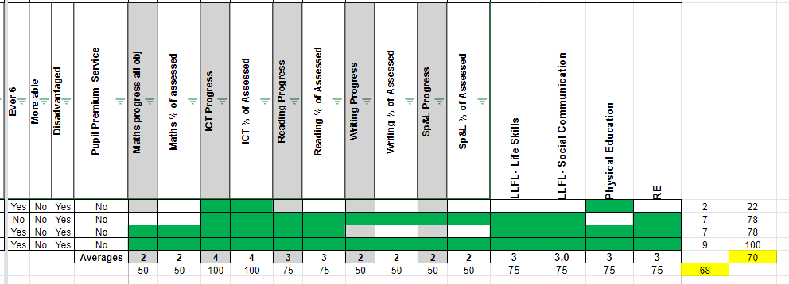

Year 11 Pupil Progress Information for Functional Skills subject areas - English, Maths and ICT progress towards targets:

All Pupils:

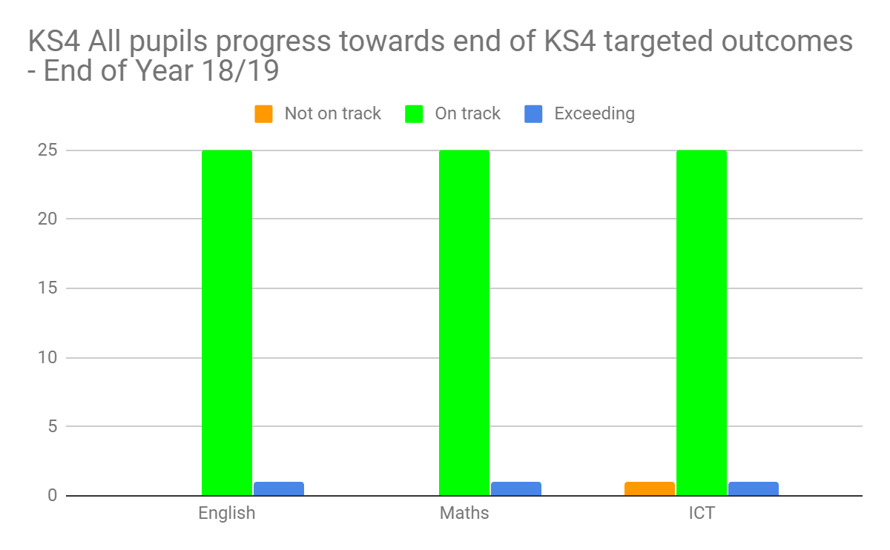

Year 11 pupils have sat Functional Skills exams. All pupils have achieved the level they were entered for with the exception of one pupil who will not be entered for L1 ICT and will remain at EL3 in ICT.

Pupil Premium Pupils:

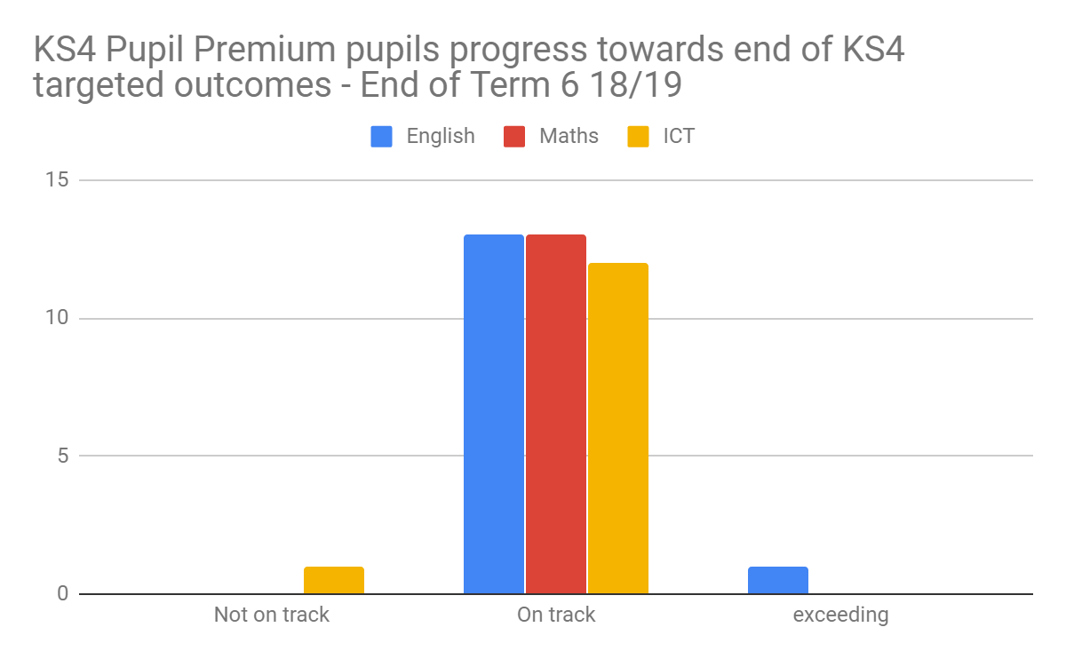

**Year 11 Accredited outcomes:**

|  |  |  |  |  |
| --- | --- | --- | --- | --- |
| Functional skills | EL2 | EL3 | Level 1 | Level 2 |
| English | 2 pupils (12%) | 6 pupils (35%) | 6 pupils (35%) | 3 pupils (18%) |
| Maths | 1 pupil (6%) | 6 pupils (35%) | 7 pupils (41%) | 3 pupils (18%) |
| ICT |  | 5 pupils (29%) | 11 pupils (65%) | 1 pupil (6%) |
| **All pupils on site are leaving with a Functional Skills qualification in English, Maths and ICT** | | | | |

|  |  |  |  |
| --- | --- | --- | --- |
| BTEC Applied Science | BTEC Home Cooking | BTEC Sport and Active Leisure | ASDAN PSD |
| Level 1 Certificate: 71%  Level 1 Award: 29% | Level 2: 94%  Level 1: 6% | Level 1: 41%  EL3: 59% | Level 1: 35%  EL3: 65% |
| **All pupils on site are leaving with a BTEC in Applied Science, Home Cooking and Sport and Active Leisure as well as an ASDAN Personal and Social Development qualification** | | | |

Duke of Edinburgh achievements:

|  |  |
| --- | --- |
| **Silver** | **Bronze** |
| 94% | 6% |
| **All Year 11 pupils on site will leave with a Duke of Edinburgh Award.** | |

GCSE results:

|  |  |
| --- | --- |
| **English** | **Maths** |
| 2 pupils - 2 grade 4 | 2 pupils - 1 grade 3 (to be remarked as it was 2 marks off a grade 4) and one grade 4 |